**Scholars Journal of Medical Case Reports**  

Abbreviated Key Title: Sch J Med Case Rep

**Radiology**

ISSN 2347-9507 (Print) | ISSN 2347-6559 (Online)

Journal homepage: https://saspublishers.com

**Posterior Nutcracker Syndrome: A Case Report**

Bouelhaz1*, A. Diani1, M.R. Bouroumane1, M. Benzalim1, S. Alj1

1Department of Radiology, Ibn Tofail Hospital, Mohammed VI University Hospital Center, Marrakech, Morocco

**DOI:** https://doi.org/10.36347/sjmcr.2025.v13i07.024 | **Received:** 29.05.2025 | **Accepted:** 08.07.2025 | **Published:** 14.07.2025

**\*Corresponding author:** Bouelhaz

Department of Radiology, Ibn Tofail Hospital, Mohammed VI University Hospital Center, Marrakech, Morocco

|  |  |  |
| --- | --- | --- |
| **Abstract** |  | **Case Report** |

|  |
| --- |
| Posterior Nutcracker Syndrome (PNCS) is a rare vascular disorder caused by the compression of the left renal vein between the aorta and the vertebral column, leading to venous hypertension and potential complications such as hematuria, flank pain, and pelvic congestion. We report the case of a 36-year-old female with a history of rheumatoid arthritis, presenting with chronic left flank pain and mild hematuria. Imaging revealed a duplicated left renal vein with stenosis of the retro-aortic segment, confirming the diagnosis of PNCS. Given the absence of significant renal or vascular complications, conservative management with clinical monitoring was chosen. This condition remains underdiagnosed due to its variable clinical presentation, and imaging techniques such as CT angiography and Doppler ultrasound are essential for diagnosis. Treatment depends on symptom severity, with conservative management preferred in mild cases and surgical or endovascular intervention required for severe cases with persistent hematuria or refractory pain. PNCS should be considered in the differential diagnosis of unexplained left-sided abdominal pain and hematuria, particularly in young patients, as early recognition is crucial to prevent complications such as venous thrombosis and irreversible renal damage.  **Keywords**: Posterior Nutcracker Syndrome (PNCS), Left renal vein compression, Hematuria, Flank pain, CT angiography. |

**Copyright © 2025 The Author(s):** This is an open-access article distributed under the terms of the Creative Commons Attribution **4.0 International License (CC BY-NC 4.0)** which permits unrestricted use, distribution, and reproduction in any medium for non-commercial use provided the original author and source are credited.

# INTRODUCTION

Posterior Nutcracker Syndrome (PNCS) refers to the compression of the left renal vein between the aorta and the vertebral column, leading to stenosis of this portion of the renal vein and dilation of its distal segment. [1, 2] This rare condition is significant due to the potential complications it may cause, including secondary anemia, hematuria, long-term left renal vein hypertension, vascular thrombosis, and the risk of blood clots within the urinary system. [2] The compression of the left renal vein can also induce a venous stasis within the pelvis, leading to dilation of the left ovarian vein, which drains into the renal vein. [3]

The clinical presentation of posterior Nutcracker syndrome can often be nonspecific and is frequently misdiagnosed, as it may present as atypical flank pain, hematuria, or other related symptoms. In some cases, the condition remains asymptomatic, while in others, it can significantly affect the quality of life of patients. Although rare, this syndrome requires a high level of clinical suspicion, especially when patients present with unexplained left-sided symptoms or recurrent hematuria. [4]

We report a case of posterior Nutcracker syndrome, highlighting the challenges in diagnosis and the importance of imaging techniques, particularly CT scan, in confirming the diagnosis and guiding treatment.

# CASE PRESENTATION

We present the case of a 36-year-old female patient with a history of rheumatoid disease, currently on methotrexate treatment (15 mg, one tablet every other day). She was referred for evaluation due to complaints of left flank pain, which had been evolving for the past year. The pain was intermittent, with no associated fever or significant alteration in her general condition. Despite the pain, the patient maintained her usual daily activities without any noticeable changes in overall health.

On further questioning, she reported no significant weight loss or gastrointestinal symptoms. However, she did mention experiencing mild hematuria**.** Her past medical history is significant for rheumatoid arthritis, for which she has been under regular follow-up and treatment with methotrexate for several years. The patient denied any history of trauma or other recent significant changes in health status. Her family history was unremarkable for renal or vascular diseases.

Physical examination revealed mild tenderness on palpation of the left lumbar region, but no signs of acute distress or fever. No abdominal masses or organomegaly were noted on palpation. Blood tests revealed no significant abnormalities, and inflammatory markers remained within normal limits, consistent with the absence of an acute inflammatory process.

Given the persistent left flank pain, an abdominal CT scan was performed, which revealed a duplicated left renal vein. The scan showed a pre-aortic trunk that drains normally into the inferior vena cava and a retro-aortic trunk presenting a narrowing between the aorta and the vertebral column, with a tapered appearance. This segment remained opacified by contrast material, confirming the venous compression. Additionally, pelvic varices were noted on imaging.

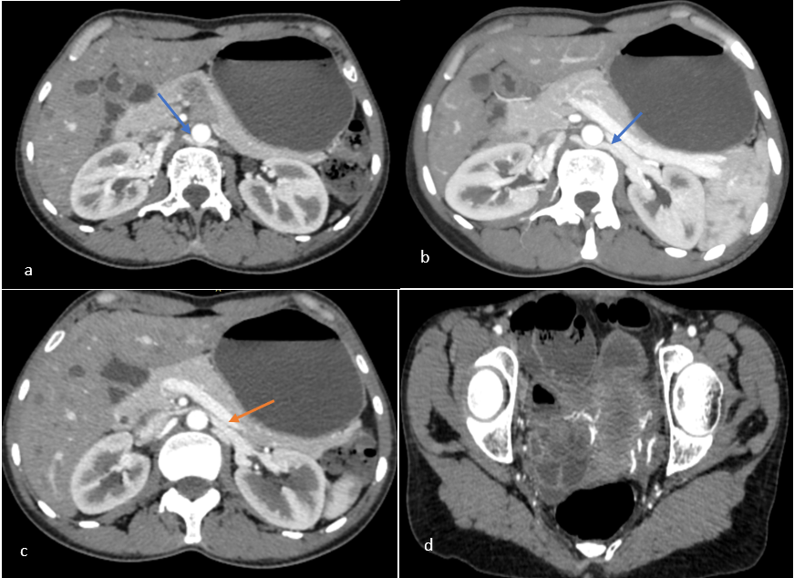

**Figure 1:** **Axial CT-enhanced images (a, b, c, d) showing a duplicated left renal vein. The scan reveals a pre-aortic trunk draining normally into the inferior vena cava (c, orange arrow) and a retro-aortic trunk with a narrowing between the aorta and the vertebral column, displaying a tapered appearance (a, b, blue arrow). This segment remained opacified with contrast, confirming venous compression. Additionally, pelvic varices were noted on imaging (c)**

These findings were consistent with posterior Nutcracker syndrome, and the patient was referred to a multidisciplinary team for further evaluation. Treatment options were discussed, including conservative management with pain relief and close monitoring, as the condition was not causing significant renal or vascular complications at the time. Follow-up imaging will be conducted to assess for any progression of the venous compression and to monitor for any potential secondary effects such as renal vein thrombosis or hematuria.

**DISCUSSION**

# Nutcracker Syndrome (NS) refers to the symptoms related to venous stasis caused by compression of the left renal vein (LRV), either between the aorta and the superior mesenteric artery (SMA) (anterior nutcracker syndrome) or between the aorta and the spine when the left renal vein passes abnormally behind the aorta (posterior nutcracker syndrome). [5]

# According to Shin and Lee, [6] this term should be reserved for patients with clinical symptoms associated with these anatomical features, as there are similar anatomical variations without clinical repercussions. In such cases, the term "nutcracker phenomenon" should be used instead. This entity was first described by the pathologist Grant in 1937, [7] and the first clinical case was reported by El-Sadr and Mina in 1950.[8] There are two types of NS: the more classic anterior type, related to compression of the LRV between the SMA and the aorta, and the rarer posterior type, where the LRV is compressed between the aorta and the vertebral body when it is retro-aortic. Both types can occasionally coexist in cases of duplicated LRV. [9]

# Several anatomical anomalies are typically described to explain the pathophysiology of NS, including a dorsolateral ptosis of the left kidney with stretching of the renal vein, abnormal direction of the vein, a low or lateral origin of the SMA, or the presence of a "fibrous tunnel" constricting the vein between the SMA and the aorta. [10,11] The exact prevalence of NS is unknown due to the variability of symptoms, lack of diagnostic criteria, and the small number of reported cases. [11] It is believed that NS is slightly more common in women, typically presenting up to 70 years of age, with a peak frequency among younger women (20 to 40 years old). The age of our patient aligns with the literature, being 36 years old.

# The clinical manifestations are varied and induced by venous stasis upstream of the LRV: asymptomatic microscopic hematuria, macroscopic hematuria, left-sided abdominal or flank pain sometimes accompanied by nausea or vomiting, and orthostatic proteinuria. Reflux into the left gonadal vein may occasionally lead to pelvic congestion syndrome, with symptoms exacerbated by sitting or standing, and may be associated with pelvic varices, dyspareunia, dysuria, dysmenorrhea, and varicocele with testicular pain in men. These symptoms can vary widely and are sometimes difficult to correlate with the anatomical findings: some individuals with marked compression of the LRV are entirely asymptomatic. [5]

# NS is likely underdiagnosed because it is often recognized late. The diagnosis is based on a detailed medical history and a thorough physical examination. More common renal pathologies must be excluded using standard diagnostic techniques. NS is usually suspected based on angiographic CT or MRI. In these cases, Doppler ultrasound can be very useful in confirming the diagnosis if the ratio between the maximum velocity of the LRV at the stenosis and the maximal upstream distension is greater than or equal to five (sensitivity of 69–90% and specificity of 89–100%). [6] A complementary diagnostic confirmation can be provided by phlebography, which measures the pressure gradient between the IVC and LRV: this gradient is typically 1 mmHg but at least 3 mmHg in cases of NS. [6]

# Various treatment options have been proposed for Nutcracker Syndrome (NS), depending on symptom severity. In cases of occasional left flank pain or mild microscopic hematuria, longitudinal observation is the preferred approach. However, severe and persistent pain or significant hematuria require intervention, as untreated stenosis can lead to venous thrombosis and irreversible kidney damage. [6,9] Conservative management is recommended for mild cases, particularly in individuals under 18, as spontaneous resolution occurs in 75% of patients due to collateral vein development. In severe cases, delaying treatment increases the risk of chronic glomerulopathies and gonadal vein dilation. When intervention is necessary, options include nephropexy, left renal vein bypass, transposition, renal-caval shunt, renal autotransplantation, gonadocaval bypass, and nephrectomy. [12, 13] Stenting has also emerged as a viable technique. In cases of severe pelvic congestion syndrome, ovarian vein embolization has shown success in 56-98% of patients. Our patient, currently asymptomatic, will be monitored, with further investigation and treatment considered if symptoms develop.

# CONCLUSION

# Posterior Nutcracker Syndrome is a rare but important condition to consider in the differential diagnosis of unexplained abdominal pain in young patients, particularly when the pain is left-sided and associated with hematuria. Early recognition is essential to prevent complications and guide appropriate management.

# Conflicts of Interest: The authors declare no conflicts of interest.

# Contributions of the Authors: All authors contributed to the conduct of this work. They have read and approved the final version of the manuscript.

**REFERENCE**

1. Lau JL, Lo R, Chan FL, Wong KK. The posterior “nutcracker”: hematuria secondary to retroaortic left renal vein. *Urology*. 1986;28(5):437–9.
2. Sato Y, Yoshimura A, Sakai H, Yogi S, Kai Y, Ideura T. A case of posterior nutcracker syndrome occurring in pregnancy. *Nihon Jinzo Gakkai Shi*. 1997;39(8):790–3.
3. Ananthan K, Onida S, Davies AH. Nutcracker syndrome: a rare cause of abdominal and pelvic pain. *Vasc Endovascular Surg*. 2017;51(4):220–4. doi:10.1177/1538574417700890
4. He Y, Wu Z, Chen S, Tian L, Li D, Li M, *et al.,* Nutcracker syndrome—how well do we know it? *Urology*. 2014;83(1):12–7. doi:10.1016/j.urology.2013.08.051
5. Berthelot JM, Douane F, Maugars Y, Frampas E. Le syndrome nutcracker : une cause rare de douleurs lombaires. *Rev Rhum*. 2016.
6. Shin JI, Lee JS. Nutcracker phenomenon or nutcracker syndrome [letter]? *Nephrol Dial Transplant*. 2005;20:2015.
7. Grant JCB. *A method of anatomy, descriptive and deductive*. 3rd ed. Baltimore (MD): Williams & Wilkins Co; 1944.
8. El-Sadr AR, Mina E. Anatomical and surgical aspects in the operative management of varicocele. *Urol Cutaneous Rev*. 1950;54:257–62.
9. Kurklinsky AK, Rooke TW. Nutcracker phenomenon and nutcracker syndrome: a review. *Mayo Clin Proc*. 2010;85:552–9.
10. Hohenfellner M, Steinbach F, Schultz-Lampel D, Schantzen W, Walter K, Cramer BM, *et al.,* The nutcracker syndrome: new aspect of pathophysiology, diagnosis and treatment. *J Urol*. 1991;146:685–8.
11. Shokeir AA, El-Diasty TA, Ghoneim MA. The nutcracker syndrome: new methods of diagnosis and treatment. *Br J Urol*. 1994;74:139–43.
12. Mallat F, Hmida W, Jaidane M, *et al.,* Nutcracker syndrome complicated by left renal vein thrombosis. *Case Rep Urol*. 2013;2013:168057. doi:10.1155/2013/168057
13. Jin M, Hu P, Ding R, *et al.,* Effectiveness of supine/standing urinalysis for differential diagnosis of left renal vein entrapment syndrome combined with or without glomerulopathy. *Nephrology (Carlton)*. 2014;19:332–8.